**Tweeting Images of Fandom: A Geographic Photo Analysis of Southeastern Conference Football Support**

*J. A. Cooper | The University of Tennessee, Knoxville*

Keywords: Twitter, Cultural identity, US South, American college football, sports fandom

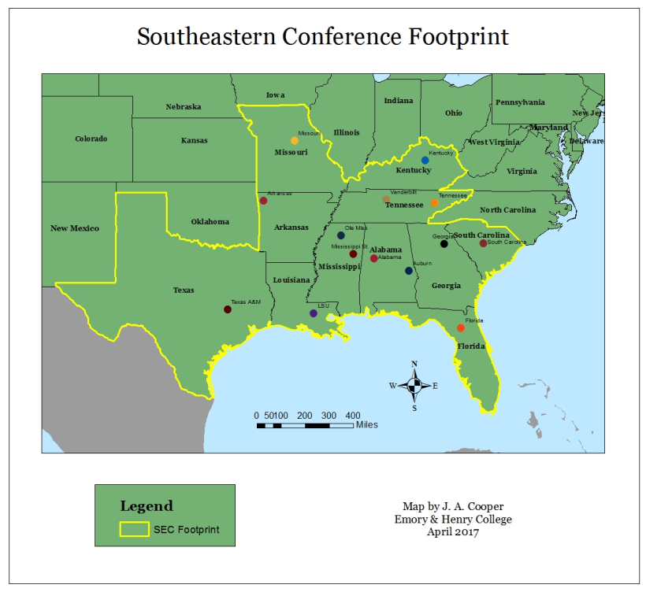

[Map above should be reproduced from attached GIS files in the FOCUS format and displayed up until the first photo]

College football is a United States phenomenon that occurs every autumn. Much of the attention given to the sport is usually directed towards the competitive game itself. Entire media apparatuses exist to predict and retrospectively analyze the outcomes of college football games. However, this is to serve fanbases across the country that invest in following their football team throughout the course of a season. Popular support for college football teams is visible in American culture through inscriptions in the landscape, consumptive economic activities, and altered mobility dynamics in host cities and towns on gamedays. A heightened affinity exists for the following of college football in the southern United States, and football contributes greatly to the cultural geography of many areas in the US South (Morgan & Klimasewski 2015). For many regional residents, their support for their favorite college football team, especially those members of the Southeastern Conference (SEC), helps them to define and construct a place identity.

The academic study of sport within and outside the discipline of geography has traditionally focused on player production origins and the marketing and management of mega sports events (Wise & Kohe 2020, see Rooney 1969, Hetherington 1993, Lee et al. 2011, Menaker & Chaney 2014). However, there is a need to further examine vernacular, grassroots sports fandom and the ways in which support of sports teams impacts landscapes, identities, lifestyles, the environment, and human dynamics. While focusing on more popular actors like players, coaches, or managerial staff within various sports apparatuses is useful for garnering a greater understanding of competitive and recreational cultures and geographies, everyday fans deserve attention for the roles they play in the economic and cultural development of sport and tourism within society.

A widespread tool of fandom available to many of these common fans is social media. Fandoms and fanbases are constructed as imagined communities that support themselves by continued affirmation and recreation (Anderson 2016, Hills 2002).  Social media has proven to be a useful apparatus for fanbases seeking to do this because it instantly connects groups with common interests across any distance to show a collective simultaneous attention to an event or matter (Dillette et al. 2019). Social media platforms like Twitter are useful in conducting geographic research because the media is generated in spaces and places that give insight into how, where, and when people (re)create places (Poorthuis et al. 2016, Metzger et al. 2016, Arthur & Williams 2019). Game days are particularly good times to study these fan cultures because of fans’ observance of pregame and game-time rituals. Rituals should not be misconstrued as banal, mundane activities; rather, ritual can give meaningful insight into societies, cultures, and communities (Turner 1969, Geertz 1972).

This project therefore uses Twitter to examine the dynamics of college football fandom on game days in the US South in relation to fans’ place identity and construction of a community of fandom. Only tweets from public accounts were used. To search for relevant tweets, “vaguely purposive” (Reed 1976, 926) keywords like “game day” and “tailgate” were used in conjunction with official and unofficial team hashtags (Notes 1 & 2). Hashtags succinctly group tweets and their text, pictures, or videos to a single topic on Twitter, and these hashtags can be used to foster virtual community construction (Dillette et al. 2019). This essay employs a twist on volunteer employed photography, a research method that is valuable in studying sport and its actors’ relationship to place and space (Hinch & Kono 2018). These photos were volunteered on public accounts into the public domain of Twitter. Social media photos are particularly useful in photography analyses because text usually accompanies the pictures that can complement, explain, and in some ways complicate the image or the user’s intent in posting it.

This essay is focused on bottom-up fandom, so while most of the pictures returned by the query that was used to search Twitter (Notes) were generated by the official football accounts of the SEC schools, only photos posted by other non-affiliated users were employed here. Additionally, when a Twitter account was a personal one (neither a fan nor a verified account), no ancillary information about the user was gleaned or used. If the user was verified as a public figure, further exploration of their profiles occasionally contributed to the discussion.

Considering the power of the internet and social media to allow users to express both fandom and place-based identity, this piece works to investigate and contextualize the various ways in which Twitter users express Southeastern Conference football fandom through photos. The analysis will seek to qualitatively explore different ways in which imagined communities and places within the US South are constructed and created through experiences of college football fandom.

[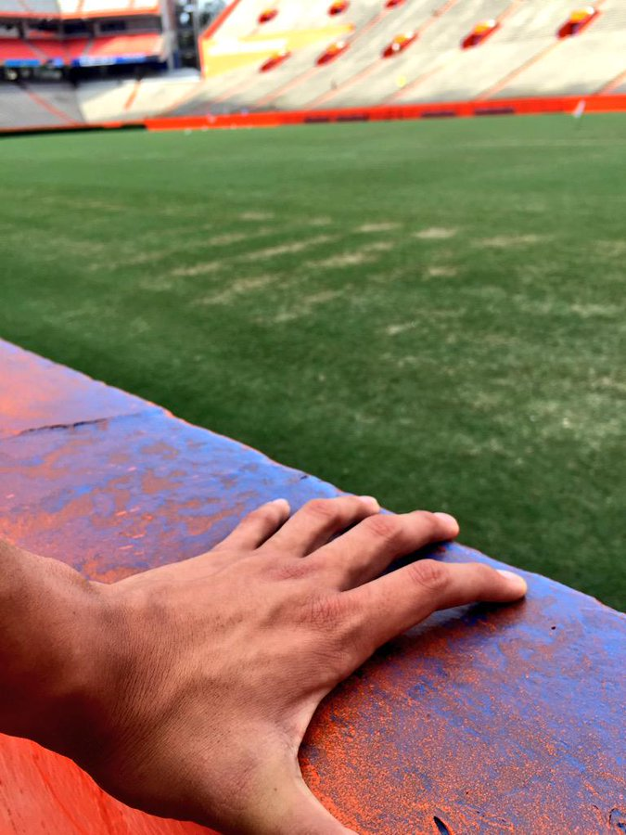](https://twitter.com/rmarin93/status/626159903258877952/photo/1)

[[Ben Hill Griffin Stadium](https://goo.gl/maps/rX62vEaUA9Urw7GZ8) – Gainesville, FL: 29.649848, -82.348649]

**[Renee G](https://twitter.com/retiremomsrmg)**[@retiremomsrmg](https://twitter.com/retiremomsrmg)

[#grip](https://twitter.com/hashtag/grip?src=hash) the swamp because we only have 39 days until [#Gameday](https://twitter.com/hashtag/Gameday?src=hash) [@UFRecSports](https://twitter.com/UFRecSports) [#ufpreview](https://twitter.com/hashtag/ufpreview?src=hash) [#GoGators](https://twitter.com/hashtag/GoGators?src=hash)

[6:38 PM - Jul 28, 2015](https://twitter.com/retiremomsrmg/status/626159903258877952)

1. SEC football fandom is not reserved exclusively for the fall. After the triumphs or defeats of the previous autumn, fans often follow their teams during the off-season through recruiting in the spring and practice in the summer in anticipation of the next upcoming season. Noted sports geographer John Bale includes anticipation as a vital part of the sports spectator’s experience (2003, 120). Football is one of the shorter seasons in college sports, and if the sport is an important component of one’s collective regional identity, that fan will attempt to stay connected to the sport outside of the autumn season. A considerable number of hours on ESPN’s SEC television network is devoted to covering the 14 teams’ off-season activities because there is a market for this coverage due to this anticipation. Social media serves as a year-round platform where fans can continually engage with their collective support. This fan’s tweet shows an empty Ben Hill Griffin Stadium with a countdown until gameday. There is a potential energy communicated in this visual: the stadium is not yet full of its thousands of fans, the field is not yet primed and painted for the action, and the athletes are nowhere to be seen. And yet, there is an excitement and longing for the eventual time when the pageantry of gameday is realized and the ritual is rejuvenated.

[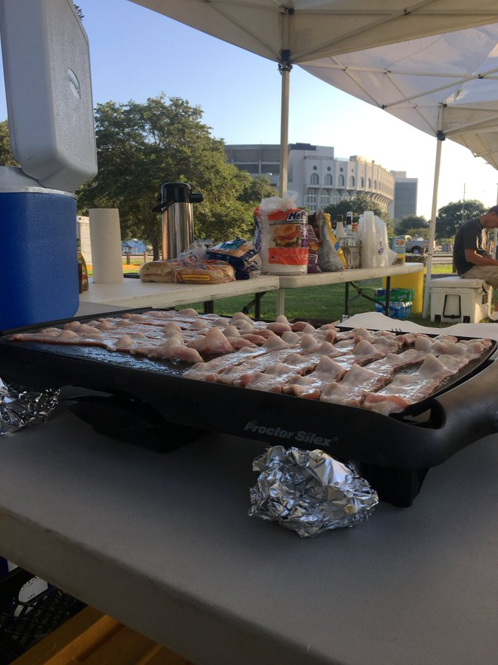](https://twitter.com/280sportfish/status/914116577590677504/photo/1)

[[Tiger Stadium](https://goo.gl/maps/5QBaDQ9hyWFTSHEP6) – Baton Rouge, LA: 30.411961, -91.183838]

**[288seafox](https://twitter.com/288seafox)**[@288seafox](https://twitter.com/288seafox)

Breakfast, gameday, tiger stadium. No better place [#geauxtigers](https://twitter.com/hashtag/geauxtigers?src=hash)

[9:15 AM - Sep 30, 2017](https://twitter.com/288seafox/status/914116577590677504)

1. After anticipating the journey, the next steps in Bale’s (2003) spectator’s experience sequentially include the journey to spectate and then the on-site stadium experience itself. In theorizing specifically the spectator experience of American college football, it would be useful to add another step in between the journey and the game: tailgating. Fans of the SEC tend to take their tailgating very seriously. *Southern Living*, a magazine that serves as a guide for how a good Southerner lives in the exceptional South (Lauder 2012), has published two editions of the SEC tailgating cookbook to capitalize upon the fact that this particular ritual is a vital part of gameday for many ticket holders. This tweet from 2007 was sent at 9:15 AM showing off a fully set-up tailgating scene in Baton Rouge, Louisiana. The sender contently declares his/er place to be superior to all others because of the food, event, and stadium view. Cooking food is a very common component of tailgating, and this fan is showing that s/he is so committed that they began cooking early in the morning for what was that day a 7:00 PM game. In the background is Tiger Stadium where the tailgater’s LSU team would play later that day. Again, we see the stadium as a significant icon for fans as they express their fandom. Participation in the tailgating ritual on a gameday in proximity to this cathedral creates for this tweeter the ideal place and experience.

[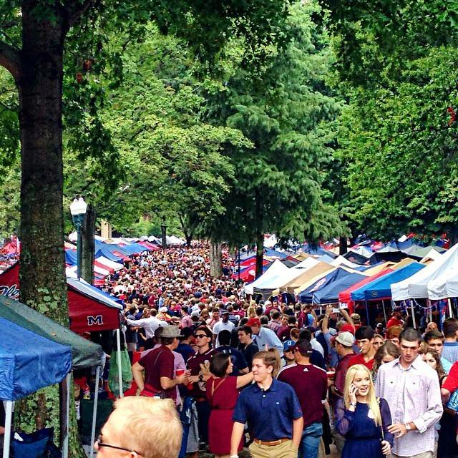](https://twitter.com/RebelPix/status/504993397732802560/photo/1)

[[The Grove](https://goo.gl/maps/M8A5V6qRQ2tpkzEH6) – Oxford, MS: 34.365715, -89.532665]

**RebelPix**@RebelPix

Guys, IT'S GAMEDAY [#HottyToddy](https://twitter.com/hashtag/HottyToddy?src=hash) [#BeatBSU](https://twitter.com/hashtag/BeatBSU?src=hash) [#OleMiss](https://twitter.com/hashtag/OleMiss?src=hash) [#MostBeautifulPeopleAlive](https://twitter.com/hashtag/MostBeautifulPeopleAlive?src=hash) by badamhill

7[9:06 AM - Aug 28, 2014](https://twitter.com/RebelPix/status/504993397732802560)

1. The University of Mississippi’s tradition of tailgating is to convert the campus’s central quad known as “The Grove” into a pregame festival. This tweet’s photo is not focused on any one tailgate but rather on the vast nature of all the tailgates together. The Grove is known for both the sheer mass of people who congregate there on gamedays and for its excessively posh tailgating atmosphere where people are known to use crystal drinking glasses and fine tablecloths under their tents.

A component of these formalities at Ole Miss is that many tailgaters will dress nicely for the day. These essentially Southern standards are reflected and reestablished by media (like *Southern Living*) and stores (like Belk, an official corporate sponsor of the Southeastern Conference, whose most recent tagline is “Modern. Southern. Style.”). This expectation of elegance is reflected by this fan account’s tweet declaring The Grove as a collective fan community to be the “#MostBeautifulPeopleAlive.” Like marketing and other media, social media works as a force to (re)create social standards (see Haenschen 2016, Stephens & Poorthuis 2015). In order to claim membership in the Ole Miss community, to truly be excited for a football game in Oxford, and to be a respectable spectator, a Rebel fan must achieve a status of beauty. Notice also the racial makeup of this collective fan community: the majority of the visible faces in this picture appear white. This racial construction of beauty and ideal fandom then establishes whiteness as a part of the elegant pageantry vital to Ole Miss football fandom.

[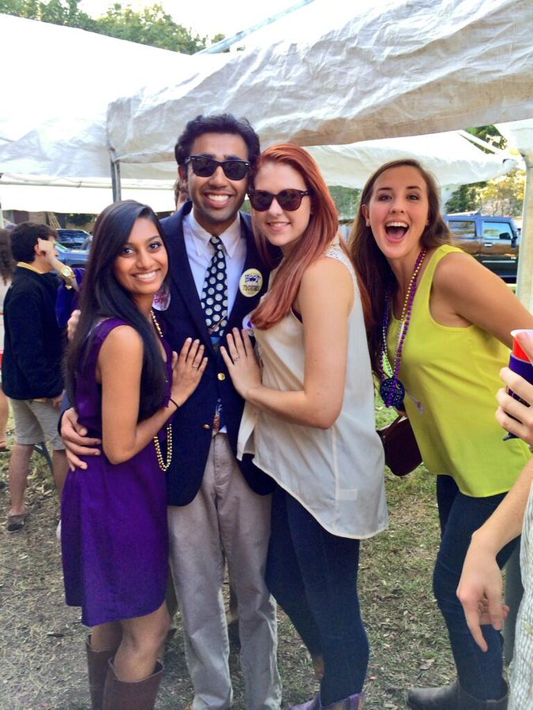](https://twitter.com/GeauxMaddie/status/394304892648448000/photo/1)

[[Tiger Stadium](https://goo.gl/maps/5QBaDQ9hyWFTSHEP6) – Baton Rouge, LA: 30.411961, -91.183838]

**[Maddie Samuels](https://twitter.com/GeauxMaddie)**[@GeauxMaddie](https://twitter.com/GeauxMaddie)

[Gameday with my bestest friends!!!](https://twitter.com/intent/like?tweet_id=394304892648448000" \o "Like) [[#GeauxTigers](https://twitter.com/intent/like?tweet_id=394304892648448000" \o "Like)](https://twitter.com/hashtag/GeauxTigers?src=hash)[[#tailgate](https://twitter.com/intent/like?tweet_id=394304892648448000" \o "Like)](https://twitter.com/hashtag/tailgate?src=hash)[[#homecoming](https://twitter.com/intent/like?tweet_id=394304892648448000" \o "Like)](https://twitter.com/hashtag/homecoming?src=hash)

[11:29 PM - Oct 26, 2013](https://twitter.com/GeauxMaddie/status/394304892648448000)

1. While the elegance is emphasized at Ole Miss, other SEC schools’ fans also use gameday as an event for which to spiff up and look their best. This tweet from LSU focuses on presumably undergraduate fans preparing for the game, and all are dressed nicely. This photo, unlike the previous ones, is less concerned with the landscape of tailgating than the people who construct and participate in the experience. For this tweeter, the important aspect of gameday is not necessarily the competition, the food, the clothes, or the tradition (though some or all of those are certainly connoted); rather, it is the friendship, community, and relationships engendered in the midst of the ritual that matter.

For college students, home gamedays often serve as respites from schoolwork. Notice the cup that is partially visible in the right of the frame. The red solo cup is a US cultural icon for parties and tailgates, and it is frequently referenced in works of popular culture like [Toby Keith’s 2011 song, “Red Solo Cup.”](https://www.youtube.com/watch?v=BKZqGJONH68)Research finds that alcohol consumption increases on college football game days at the home campus (Menaker & Chaney 2014). Though a majority of undergraduates are under the legal drinking age in the United States (21), alcohol, often found in disposable plastic cups like this one, is usually included in students’ weekend tailgates with friends. This tweeter is expressing her fandom by emphasizing friendship and more subtly including alcohol.

[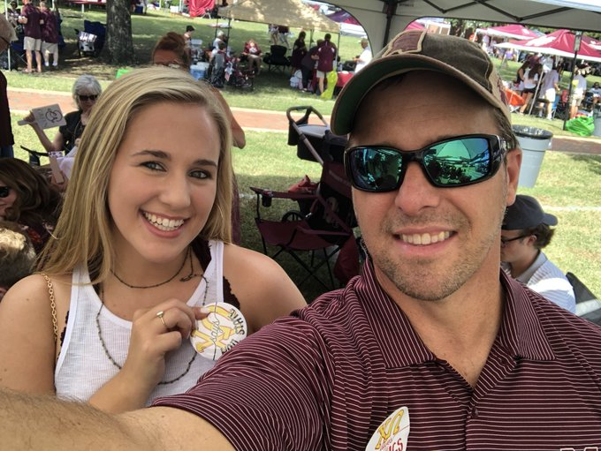](https://twitter.com/uncle_seven/status/1035986518932897792/photo/1)

[[Davis Wade Stadium](https://goo.gl/maps/rBLapy1mXo4hub2NA) – Starkville, MS: 33.456354, -88.793373]

**[Uncle Enneagram 7](https://twitter.com/uncle_seven)**[@uncle_seven](https://twitter.com/uncle_seven)

First time [#tailgating](https://twitter.com/hashtag/tailgating?src=hash) as a [#ChiO](https://twitter.com/hashtag/ChiO?src=hash) dad! [#HAILSTATE](https://twitter.com/hashtag/HAILSTATE?src=hash) [@HailStateFB](https://twitter.com/HailStateFB)

[4:23 PM - Sep 1, 2018](https://twitter.com/uncle_seven/status/1035986518932897792) · [Starkville, MS](https://twitter.com/search?q=place%3Aed1736d76c1e007c)

1. In researching the American college town, geographer Blake Gumprecht (2008) found that Greek life dominates formal aspects of student life on college campuses. This is apparent at SEC tailgates and football games. Fraternity and sorority members often congregate with other members of their organization to participate in the many gameday activities. Unlike their peers’ more informal friendly gatherings, Greeks usually brand themselves not only with their team’s logo but with their organization’s letters as well. This display of community membership is a point of pride, distinctiveness, and honor for members.

In this tweet, a new sister of Chi Omega at Mississippi State emphasizes her sorority’s button as a focal point of her gameday experience. The tweeter is her father who is also proudly wearing Chi-O letters on his shirt along with the Mississippi State logo. Tradition is a popularly lauded ideal in the Southern gameday rituals, and both Greek organizations and familial ties are a part of that tradition. The commonly used saying of “Faith, Family, Football” is meant to indicate the traditions of these rituals. This father is evoking the family and football tradition by sharing with the world his observance of the ritual with his daughter. He also emphasizes his daughter’s acceptance into a new family: a sorority. Greek organizations often use familial diction in defining members’ roles. And, if an inductee’s blood relative was also once a sorority or fraternity member, they can sometimes even inherit membership into that Greek organization. This father is clearly pleased with both his daughter’s observance of the tailgating tradition of gameday with him and the infusion of sorority membership into the ritual.

[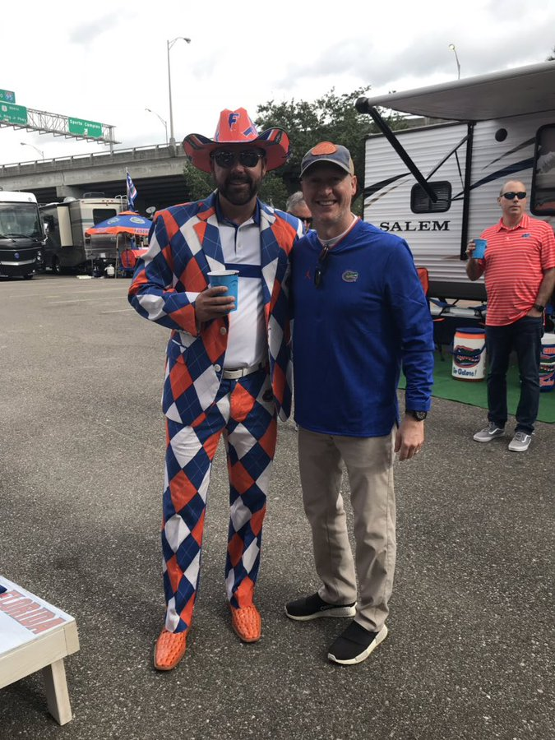](https://twitter.com/bobounds/status/1056208597133262850/photo/1)

[Jacksonville, FL near TIAA Bank Field: 30.323778, -81.637316]

**[Out of Bounds](https://twitter.com/bobounds)**[@bobounds](https://twitter.com/bobounds)

Saw my cousin at the [#tailgate](https://twitter.com/hashtag/tailgate?src=hash) [#Gators](https://twitter.com/hashtag/Gators?src=hash) [#UGA](https://twitter.com/hashtag/UGA?src=hash) [@YallLifestyle](https://twitter.com/YallLifestyle) tailgating

[11:38 AM - Oct 27, 2018](https://twitter.com/bobounds/status/1056208597133262850)

1. This next tweet is also evocative of the tradition of tailgating with family: the tweeter expresses his pleasure at his reunion with his cousin at the 2018 Florida vs Georgia game. This annual matchup played on a neutral site in Jacksonville, FL is colloquially known as the “World’s Largest Outdoor Cocktail Party,” and it is certainly possible the cup-holding Gators fans are participating in this tradition. The tweeter shared this image perhaps not just for the family connection but also for the eccentric, colorful Florida getup his cousin was donning. This speaks to an extremely common occurrence at a college football gameday: the material commodification of fandom. Sports merchandise purchasing and displaying reflects the consumer’s values and serves to emphasize his/her fandom (Lee et al. 2011). The tweeter’s cousin paid money for each item in his extensive blue-and-orange outfit so he could then display his fandom. This tweet was probably sent in part because this outfit expresses “more” fandom than the average tailgater’s does. However, the merchandise consumerism culture is not reserved for exceptional displays of fan values like this suit; also visible in this picture are Gator branded bins, cornhole boards, a chair, a tent, and even a grill. Entire economic enterprises are predicated on the popular positive correlation between merchandise consumerism and fandom, and this is reflected across cultural and gameday landscapes.

It is also worth noting that this tweeter tagged @YallLifestyle in this tweet. Further examination of that account’s website reveals that the tweeter is actually the co-founder of the company, Y’all Lifestyle. The online store markets its products by appealing to an essentially Southern way of life. The [website](https://www.yalllifestyle.com/lifestyle/)explains that the “y’all lifestyle” is about

*Living in the South. It’s tailgating on SEC campuses in the fall, where you start the morning with a Bloody Mary and “How are y’all?”, followed by the roar of a packed stadium, and then meeting up again with family and friends to celebrate the win or critique the loss – but either way, there’s never a shortage of cold beverages, good buddies or laughter close by.*

Football fandom via tailgating and game-going is integrated into a vision of a Southern lifestyle that is itself a marketing strategy: those who ascribe to this vision of southern living are being encouraged to purchase from this company that shares the ideal.

[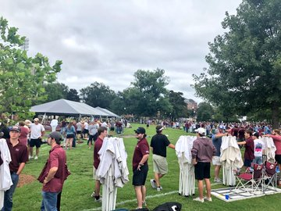](https://twitter.com/RhettHobart/status/1045777622591053824/photo/1)

[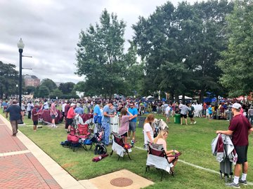](https://twitter.com/RhettHobart/status/1045777622591053824/photo/1)

[[Davis Wade Stadium](https://goo.gl/maps/rBLapy1mXo4hub2NA) – Starkville, MS: 33.456354, -88.793373]

**[Rhett Hobart](https://twitter.com/RhettHobart)**[@RhettHobart](https://twitter.com/RhettHobart)

10 minutes until The Junction opens and safe to say it’s going to be a little crowded this weekend. [#HailState](https://twitter.com/hashtag/HailState?src=hash)

[4:49 PM - Sep 28, 2018](https://twitter.com/RhettHobart/status/1045777622591053824) · [Starkville, MS](https://twitter.com/search?q=place%3Aed1736d76c1e007c)

1. This tweet reemphasizes the integration of tradition and tailgating. It refers to the Mississippi State custom of opening up its most coveted tailgating spot, The Junction, in an Oklahoma land rush-esque fashion where fans sprint to claim their plot. In Starkville, Mississippi, this pregame activity itself is a competition. Even as fans prepare to view a football contest later in the day, they will first compete for space where they can participate in the tailgating ritual. The “gaze” (Urry 2002) of the camera is focused on the fans’ anticipation, but it also shows the empty, coveted space. Why is this space so valuable? Perhaps because of the excellent proximity to the Davis Wade Stadium.

[Pan to point map of both Davis-Wade & [The Junction](https://goo.gl/maps/XX5RGfEqe1ZtMoXi7): 33.454841, -88.793800]

But also the tradition itself serves to elevate the value of this space in the tailgaters’ minds. The tradition of rushing The Junction is part of gameday for Mississippi State fans, one that, as [a fellow fan noted in a direct reply tweet](https://twitter.com/ToddBowering/status/1045780076145577984), never gets old. The rushing ritual along with other tailgating processes are themselves placemaking activities. Here, The Junction, formerly empty, grassy space, is made into a place infused with meaning by those who are lucky enough to stake their claim.

[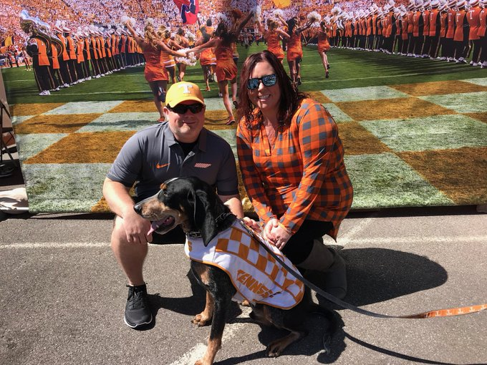](https://twitter.com/stroud023/status/1035857742882385921/photo/1)

[Charlotte, NC near Bank of America Stadium: 35.225766, -80.852887]

**[Philip Stroud](https://twitter.com/stroud023)**[@stroud023](https://twitter.com/stroud023)

[It’s game day on Rocky Top! Good luck to](https://twitter.com/intent/like?tweet_id=1035857742882385921" \o "Like) [[@Vol_Football](https://twitter.com/intent/like?tweet_id=1035857742882385921" \o "Like)](https://twitter.com/Vol_Football) [and](https://twitter.com/intent/like?tweet_id=1035857742882385921" \o "Like) [[@CoachPruitt_UT](https://twitter.com/intent/like?tweet_id=1035857742882385921" \o "Like)](https://twitter.com/CoachPruitt_UT) [in CLT today!](https://twitter.com/intent/like?tweet_id=1035857742882385921" \o "Like) [[@HeatherStroud84](https://twitter.com/intent/like?tweet_id=1035857742882385921" \o "Like)](https://twitter.com/HeatherStroud84) [and I say Go Big Orange and bring home that W!](https://twitter.com/intent/like?tweet_id=1035857742882385921" \o "Like) [[#gbo](https://twitter.com/intent/like?tweet_id=1035857742882385921" \o "Like)](https://twitter.com/hashtag/gbo?src=hash)[[#VFL](https://twitter.com/intent/like?tweet_id=1035857742882385921" \o "Like)](https://twitter.com/hashtag/VFL?src=hash)[[#RockyTop](https://twitter.com/intent/like?tweet_id=1035857742882385921" \o "Like)](https://twitter.com/hashtag/RockyTop?src=hash)

[7:51 AM - Sep 1, 2018](https://twitter.com/stroud023/status/1035857742882385921)

1. Several themes already explored appear in this tweet about the University of Tennessee: the tweeter and his wife (who is tagged in the tweet) are seen in their orange and smoky gray getup in preparation for the Vols’ season opener in 2018. Rather than a picture of the couple at an iconic pregame tradition in Knoxville like the Vol Navy or the band’s “playing to The Hill” performance outside Neyland Stadium, they are photographed in front of a backdrop of the Tennessee football team’s traditional entrance onto the field: running through the “T.”. The vantage point of the backdrop allows the couple to simulate actively participating inside this tradition that fans usually experience with a more passive voyeurism. It is unclear if this picture was taken on the day this tweet was sent, but if it was, it was shot in Charlotte, North Carolina, where Tennessee played in a neutral-site game. In this case, this backdrop serves as a way to infuse the very place-based gameday traditions of Knoxville, Tennessee, into the unclaimed no-man’s-land of Charlotte, North Carolina.

Prominently making an appearance in this tweet is Smokey, Tennessee’s live blue tick hound mascot. Mascots are icons that are frequently included in the festival of gameday; several SEC schools have dog mascots, and LSU even has a live tiger, Mike. Mascots are revered by their fans even as they are misunderstood by outsiders (see *Parks & Recreation*‘s [satire](https://youtu.be/xUvkyBH--D0)of this). Often, a team’s nickname and mascot are related (the Georgia Bulldogs’ mascot is an actual bulldog), but this is not always the case (The Alabama Crimson Tide’s mascot is an elephant). Mascots can be represented in artificial human costumes or by live animals. Regardless, they are not static sideline ornaments but can be very powerful icons evocative of a school’s history or its fans’ collective memory. Some mascots can be extremely controversial (Bever 2011), but they can also inspire a great deal of pride. Smokey is seen in this tweet as an icon of Tennessee football, and the tweeter and his wife’s proximity to the hound serves to elevate their fandom in the eyes of his followers.

[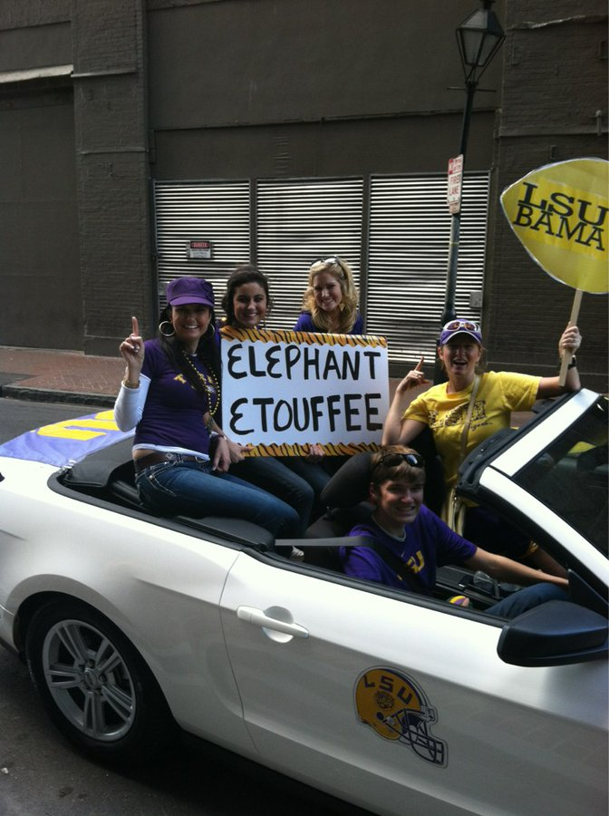](https://twitter.com/Brittany_Berry/status/156231996841000960/photo/1)

[New Orleans, LA near the Superdome: 29.950546, -90.080022]

**[Brittany Berry](https://twitter.com/Brittany_Berry)**[@Brittany_Berry](https://twitter.com/Brittany_Berry)

[Had a fun filled day cheering on the Tigers in New Orleans! I've never been more ready for a game!](https://twitter.com/intent/like?tweet_id=156231996841000960" \o "Like) [[#geauxtigers](https://twitter.com/intent/like?tweet_id=156231996841000960" \o "Like)](https://twitter.com/hashtag/geauxtigers?src=hash)[[#LSU](https://twitter.com/intent/like?tweet_id=156231996841000960" \o "Like)](https://twitter.com/hashtag/LSU?src=hash)

[12:33 AM - Jan 9, 2012](https://twitter.com/Brittany_Berry/status/156231996841000960)

1. This tweet from an LSU fan shows a local spin on the Southern tailgating tradition. Some elements remain the same: the branding of the self and automobile with team logo merchandise and the self-beautification efforts, for instance. There is also an integration of Louisiana and specifically New Orleans culture into this scene. The étouffée referenced on the alliteration sign refers to the dish commonly eaten in Louisiana, the state of both LSU and New Orleans. The elephant meat in this theoretical étouffée refers to the opponent Alabama’s elephant mascot, Big Al. This sign is meant to evoke images of hunting and dominating a lesser prey; in so doing, it glorifies the violence of college football as a sport.

Notice also that the girls holding the sign are sitting up on the convertible as if it were a float, and one is even wearing gold beads. This is evocative of Mardi Gras and the many parades that occur annually in New Orleans. Mardi Gras and other Carnival celebrations around the world are cultural rituals in their own right (Turner 1969). This picture was before the 2012 National Championship in New Orleans. Through text on a poster board and parading through the streets, these fans are signing to Alabama that this territory belongs to LSU. These fans claim the Louisiana city as their own by couching LSU traditions (a rivalry with Alabama) with those of New Orleans (particular foods and rituals) into a larger Louisiana flavor of tailgating. This is not a unique, isolated occurrence for LSU; the hashtag in this tweet (#GeauxTigers) shows support for the LSU team in the widely used, more Louisiana-French phonetic way of spelling “go.” State borders are particularly important in constructing fandoms geographically in college football (Roseman & Shelley 1988), and the combining of LSU tailgating rituals with New Orleans culinary and Mardi Gras rituals shows a particular perceived ownership of Louisiana by the LSU fanbase.

[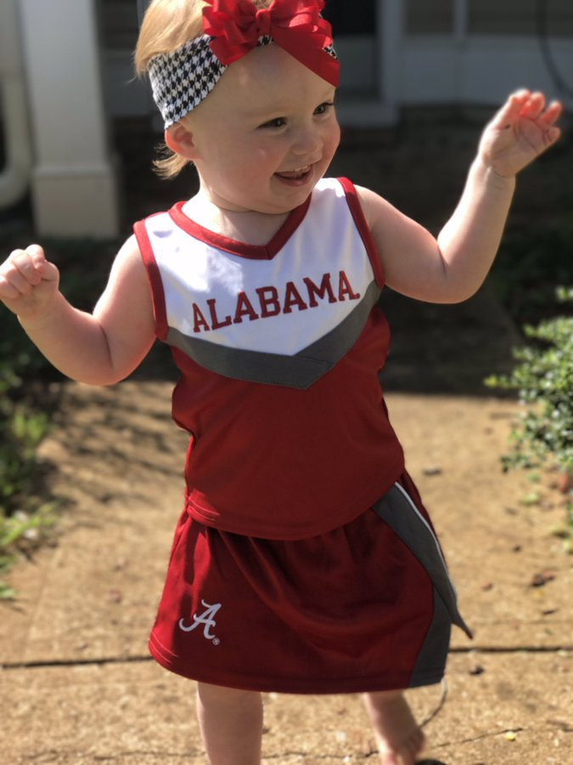](https://twitter.com/ecsprayberry/status/903997679457505280/photo/1)

[Tuscaloosa, AL: 33.207665, -87.550469]

**[Emily Sprayberry](https://twitter.com/ecsprayberry)**[@ecsprayberry](https://twitter.com/ecsprayberry)

[That face you make when you find out it's game day !](https://twitter.com/intent/like?tweet_id=903997679457505280" \o "Like) [[#RollTide](https://twitter.com/intent/like?tweet_id=903997679457505280" \o "Like)](https://twitter.com/hashtag/RollTide?src=hash)[[#RTR](https://twitter.com/intent/like?tweet_id=903997679457505280" \o "Like)](https://twitter.com/hashtag/RTR?src=hash)[[#SEC](https://twitter.com/intent/like?tweet_id=903997679457505280" \o "Like)](https://twitter.com/hashtag/SEC?src=hash)[[#gameday](https://twitter.com/intent/like?tweet_id=903997679457505280" \o "Like)](https://twitter.com/hashtag/gameday?src=hash)[[#stellagracespray](https://twitter.com/intent/like?tweet_id=903997679457505280" \o "Like)](https://twitter.com/hashtag/stellagracespray?src=hash)

[11:06 AM - Sep 2, 2017](https://twitter.com/ecsprayberry/status/903997679457505280)

1. Many fans experience college football in places away from the stadium, and this is no less significant than those tourists who attend the game in person (Roseman & Shelley 1988). It is unclear if this tweeter and her daughter featured in the image will attend the Alabama game later in the day, but the background of the picture appears to be a house, and the daughter in the foreground is outside in the yard area. Themes of family appear again in this tweet. The featured toddler has no real agency of her own to decide what, if any, college football team she would support. Here, the mother is actively passing down her Alabama fandom to her daughter in hopes that she will continue the tradition of cheering for the Crimson Tide. Just as with other merchandise sales, this tweeter has purchased a trademarked item to express her own fandom, but in this instance, she intends for her daughter to be the expresser. That is, the mother creates a character of her daughter as an Alabama fan. However, this creation and narration actually expresses her own fandom. In all likelihood, the toddler is not smiling because she realizes that the Alabama team is playing a football game that day, but her mother interprets it as such to her followers. In so doing, she expresses her own fandom as an Alabama supporter and demonstrates that she is committed to the Faith-Family-Football pillars that are tent poles to the SEC fan community and culture.

[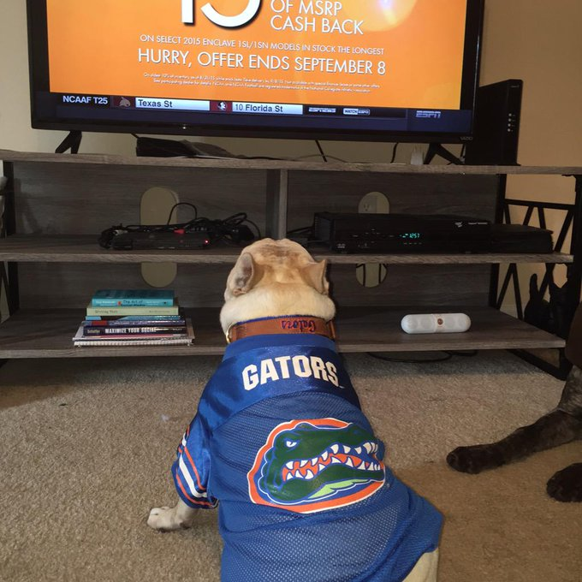](https://twitter.com/brooke_heil/status/640208169160060928/photo/1)

[Gainesville, FL: 29.649848, -82.348649]

**[Brooke Heil](https://twitter.com/brooke_heil)**[@brooke_heil](https://twitter.com/brooke_heil)

It's finally [#GameDay](https://twitter.com/hashtag/GameDay?src=hash) in the swamp! Jeffrey is patiently waiting for the [@UF](https://twitter.com/UF) game to start. [#GoGators](https://twitter.com/hashtag/GoGators?src=hash)

[1:01 PM - Sep 5, 2015](https://twitter.com/brooke_heil/status/640208169160060928)

1. This Twitter user appropriates her dog’s existence to express her football fandom much like the mother in the last tweet did with her daughter. This dog, Jeffrey, is being used as a prop to express his owner’s excitement for Florida football. The owner purchased an officially licensed Florida collar and jersey for Jeffrey and pretends that his facing the television demonstrates a similar anticipation for the upcoming contest to her own. This is a clear example of anthropomorphism, a phenomenon by which people ascribe human traits and characteristics to nonhuman agents (Epley et al. 2013). And while this fan tweets this cute anthropomorphic scene to connect with other football fans, Jeff himself probably doesn’t care much whether the team in jerseys similar to his own wins or not.

Beyond the utilization of a pet to express one’s own fandom, this tweet shows a gameday experience away from the stadium. Instead of tailgating, this tweeter has chosen to watch the game from the comfort of her own home. The television looks adequately big enough with a high enough definition to allow for an optimal viewing experience, one that many fans choose. These remote fans can use media and television to construct virtual spaces of belonging that still allow them to feel the game and perform their fandom even in their state of diaspora (Baker 2018). Jeffery, probably a usual character around the home, helps this tweeter perform her fandom even as she is excited for the game to happen where she is not (the Swamp, Florida’s football stadium).

[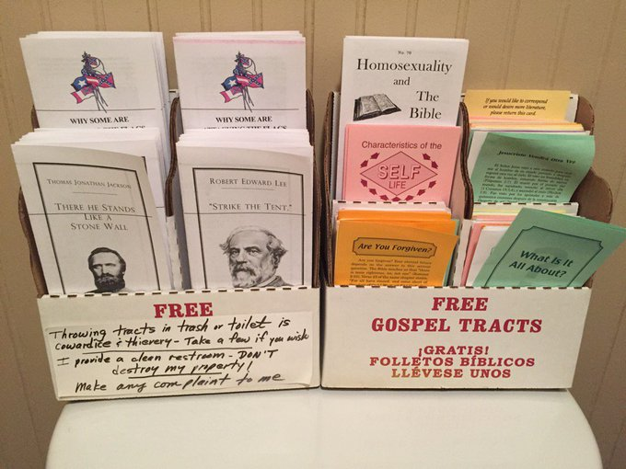](https://twitter.com/one_southernman/status/914197205103398917/photo/1)

[[Barbara Ann's Place](https://goo.gl/maps/5n4dXtRu2vN1f7XV7) – Eldridge, AL: 33.924374, -87.622680]

**[OneSouthernMan](https://twitter.com/one_southernman)**[@one_southernman](https://twitter.com/one_southernman)

Stopped at [#barbaraann](https://twitter.com/hashtag/barbaraann?src=hash)’s in [#Eldridge](https://twitter.com/hashtag/Eldridge?src=hash) [#Alabama](https://twitter.com/hashtag/Alabama?src=hash). God Bless [#Dixie](https://twitter.com/hashtag/Dixie?src=hash) [#RollTide](https://twitter.com/hashtag/RollTide?src=hash) [@AlabamaFTBL](https://twitter.com/AlabamaFTBL)

[2:36 PM - Sep 30, 2017](https://twitter.com/one_southernman/status/914197205103398917)

1. This is an example of an expression of fandom that directly conflates football fandom with larger contested regional cultures. This anonymous account by the pseudonym “OneSouthernMan,” proclaims himself in his Twitter bio a “Connoisseur of Everything Southern” including food, Southern belles, guns, politics, and SEC football. It is telling that his perception of Southern-ness includes college, specifically SEC, football. This tweet’s textual content contains the language of SEC football, but the image tells a much different story. The photo shows a collection of pamphlets, the left on icons of the Confederacy and the right on Christianity. The Lost Cause ideology in the South, evocative of the defeated Confederacy and its Antebellum predecessor, is a powerful, active, and potent mindset in the region today. This bit of misremembered, white-supremacist collective memory is often emotionally connected to the icons of the Confederacy’s flag and heroic generals (Bohland 2013), all of which are prominently displayed in these pamphlets. The placement of religious pamphlets beside the confederate ones and the invocation of God in the tweet represent the extent to which the Lost Cause as a part of a “white southern identity is tightly bound with the regional population’s fundamentalist religious practices” (Webster & Leib 2016, 32). The South is indeed often thought of as the “Bible Belt” of conservative evangelical Christianity (Brunn et al. 2011), though the right-hand pamphlets in the photo are not explicitly conservative or evangelical in nature. Specifically, the tweeter asks God to bless “#Dixie.” Dixie is a term evocative of the old Confederate south that is highly charged, radicalized, and strongly identified with in Alabama (Alderman & Beavers 1999, Cooper & Knotts 2017).

[Pan to map with two points: Eldridge and Bryant-Denny Stadium in Tuscaloosa, AL: 33.207665, -87.550469]

This tweet’s text also uses the hashtag #RollTide, the favorite saying of Alabama fans. It even tags Alabama’s official football account in the tweet. College football, specifically Alabama football, was on OneSouthernMan’s mind when he sent this tweet. Why the coupling of Alabama football, Confederate iconography and verbiage, and images of Christianity? Perhaps it is simply Eldridge, Alabama’s proximity to The University of Alabama in Tuscaloosa. However, since OneSouthernMan is an account dedicated to the expression of a decidedly white male Southern identity, this tweeter believes that the Confederacy, Christianity, and Crimson Tide are natural components of this identity. This tweet seems subtle enough, but it serves as an example of how “electronic mass media is partly responsible for making the idea of a distinctive South a social reality” (Alderman & Good 1997, 21) and how that distinctiveness can push an agenda of exclusivity. This tweet is also indicative of the depths to which SEC football is entrenched in and intertwined with one such idea of a distinctive southern identity, and it calls into question just what and for whom that southern-ness is.

[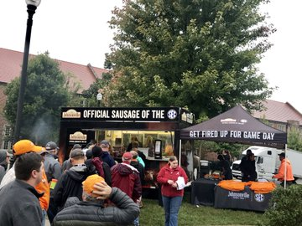](https://twitter.com/Johnsonville/status/1053678485284274176/photo/1)

[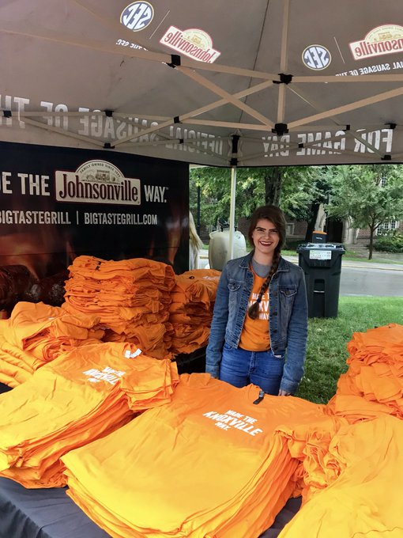](https://twitter.com/Johnsonville/status/1053678485284274176/photo/1)

[[Neyland Stadium](https://goo.gl/maps/mdMS4Pmu6x4bLq5V9) – Knoxville, TN: 35.954999, -83.924964]

**[Johnsonville](https://twitter.com/Johnsonville)**

[✔@Johnsonville](https://twitter.com/Johnsonville)

A little morning [rain emoji] couldn’t put a damper on our “Made the Knoxville Way” tailgate!   
RT if [#Johnsonville](https://twitter.com/hashtag/Johnsonville?src=hash) is your official sausage on game day! [#BigTasteGrill](https://twitter.com/hashtag/BigTasteGrill?src=hash) [#SEC](https://twitter.com/hashtag/SEC?src=hash)

[12:05 PM - Oct 20, 2018](https://twitter.com/Johnsonville/status/1053678485284274176)

1. As previously mentioned in the cases of *Southern Living*and Belk, there exist corporate actors apart from the individual fan that have recognized the importance of football fandom in the lives of SEC supporters and seek to capitalize on this fandom. Merchandise, specifically clothing, dominates most university bookstores and unofficial fan shops. Other industries have realized this marketing potential. Johnsonville sausage has a deal with the Southeastern Conference to be the official sausage brand of the league. This seems like an unnatural alliance on the surface: besides frankfurters being sold at sports events traditionally, there is nothing particularly tying link sausage to SEC football. Johnsonville was founded and is headquartered in Wisconsin, far from any state hosting an SEC institution. The sausage company though sees that attaching the SEC brand to its product and advertising it at its games will more fully open up a market in the southern US. [Other SEC sponsors](http://www.secsports.com/article/11055657/official-sec-corporate-sponsors) attempt similar strategies. This tweet shows Alabama and Tennessee fans alike lining up on a rainy third Saturday in October to buy the official sausage of the SEC that is somehow “made the Knoxville way.”

[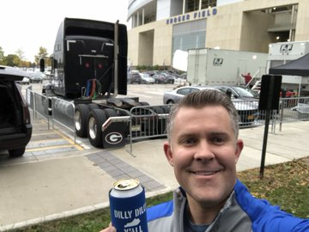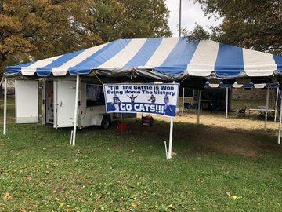](https://twitter.com/tgh3316/status/1058453961131417600/photo/1)

[[Commonwealth Stadium](https://goo.gl/maps/dTNcMXN3MfuCA3kz5) – Lexington, KY: 38.022685, -84.505152]

**[tgh3316](https://twitter.com/tgh3316)**[@tgh3316](https://twitter.com/tgh3316)

Tailgating has commenced!! [@UKFootball](https://twitter.com/UKFootball) is gonna beat the hell out of some Dawgs! [#NewSign](https://twitter.com/hashtag/NewSign?src=hash) [#TillTheBattleIsWon](https://twitter.com/hashtag/TillTheBattleIsWon?src=hash) [#BBN](https://twitter.com/hashtag/BBN?src=hash) [#GoCats](https://twitter.com/hashtag/GoCats?src=hash) [#GetUp](https://twitter.com/hashtag/GetUp?src=hash) [#LesssssssGoooooo](https://twitter.com/hashtag/LesssssssGoooooo?src=hash)

[4:21 PM - Nov 2, 2018](https://twitter.com/tgh3316/status/1058453961131417600)

1. This next tweet returns to the tailgating fields, this time in Lexington, Kentucky. This tweeter is eager to show off his newly constructed custom banner for his tailgate tent. He also establishes his proximity to the stadium where the game would later that night be played. He includes the Georgia equipment truck in his shot to go along with his highly antagonistic diction in his tweet.

The picture of the stadium is of particular interest because it shows both top-down and bottom-up corporate sponsorship. The University of Kentucky’s stadium was named “Commonwealth Stadium” for many years, but recently, Kroger purchased the naming rights to the field and facility. The new “Kroger Field” name is prominently displayed on the side of the stadium imposing and inscribing a toponymic name change onto the landscape. This is not insignificant; place naming actively allocates meanings to places, orders the ways in which people interact with their environment, and facilitates identity construction (Alderman 2015). Kroger, a Cincinnati, Ohio-based Fortune 500 corporation, is attempting to strengthen its connection to the state of Kentucky through this top-down sponsorship technique. Kroger hopes to create a positive, place-based connotation for its brand in the minds of Wildcats fans so they will hopefully become loyal grocery shoppers.

Anheuser-Busch on the other hand is attempting to drum up business using a similar appeal but with a bottom-up approach. The tweeter is displaying his “Dilly Dilly Y’all” beer koozie. “Dilly Dilly” is a recent Bud Light marketing slogan, but this is amended to appeal to Kentucky fans. The state outline of Kentucky is mapped onto the koozie, showing the beer company’s attempt to create a linkage between the beer and the state. Bud Light assumes, based on the university’s official colors on the koozie, a connection between state identity and Kentucky Wildcats fandom. Furthermore, “Dilly Dilly” becomes “Dilly Dilly Y’all,” giving a southern spin to the corporate trademark. Using this southernism further connects a state that has a complicated history with vernacular southern identity to its Southeastern Conference region. These koozies are cheap to make and can be distributed to masses of fans rather than investing in one logo/name display as Kroger did with the Wildcats’ field. This strategy is clearly working for this tweeter; he intentionally holds up his beer can to show his consumption during his tailgating along with his place identity.

[](https://twitter.com/EncoreAthens/status/511848172881465344/photo/1)

[[Encore](https://goo.gl/maps/FXHv8oCYHbhTGKzJ9) – Athens, GA: 33.958471, -83.377654]

**[Encore Athens](https://twitter.com/EncoreAthens)**[@EncoreAthens](https://twitter.com/EncoreAthens)

Are you Gameday ready?? Four shopping days left until our Dawgs are back between the hedges! [#encoreathens](https://twitter.com/hashtag/encoreathens?src=hash) [#godawgs](https://twitter.com/hashtag/godawgs?src=hash)

[8:04 AM - Sep 16, 2014](https://twitter.com/EncoreAthens/status/511848172881465344) · [Georgia, USA](https://twitter.com/search?q=place%3A7142eb97ae21e839)

1. Marketing football fandom is not only done through corporate actions, however. This tweet is from a local clothing store in Athens, Georgia, and it reminds those lady Georgia Bulldog fans of the expectation for women to look their nicest on gamedays. This tweet contains a countdown of anticipation like [the first tweet](http://t.co/gYvHeZDi4h), but this is less about excitement and more about conforming to a social expectation.

[Pan to two point map: Encore and [Samford Stadium](https://goo.gl/maps/hT74KUbSunDhniip6): 33.950342, -83.374226]

The local business evokes language and images of Georgia fandom: spelling “dogs” as “Dawgs” and referring to Samford Stadium by is commonly used name, “between the hedges.” The model in the shot wears red and has black hair. And, like many fans we’ve seen in these tweets, she is white. Probably not coincidentally, red, black, and white are Georgia’s three colors.

Substantial research suggests that American football is connected in myriad ways to masculinity (Steinfeldt et. al 2011). This tweet however, unlike others, has been directed towards the feminine fan. A mere glance at a stadium or tailgate on gameday would show that college football fans are not exclusively men. This local store understands this fact and uses the expectation of women to dress nicely in Athens when going to Georgia football games to market its clothing. While it is not unusual for men to wear coats, ties, or other nice garb to a game, the popular imaginary associates the nice dress at Southern football games primarily with women (see [this CNN article](https://www.cnn.com/2014/12/05/living/irpt-sec-football-fashion/index.html)). The dress featured in this tweet could be perfectly appealing to customers out of context with no connection to Georgia football at all. However, this store markets it using football as a social tool to create and recreate the expectations that drives its business in a college town (Gumprecht 2008).

[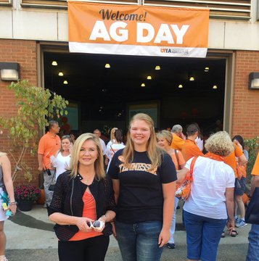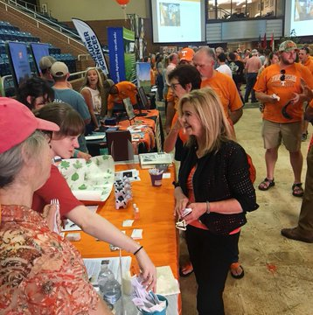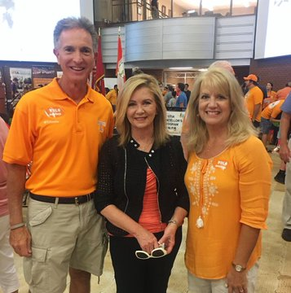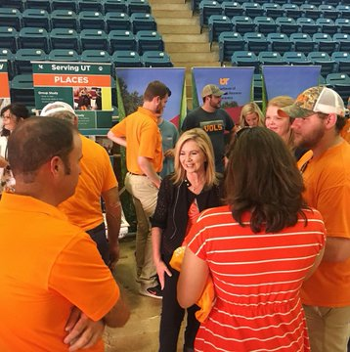](https://twitter.com/VoteMarsha/status/1043597948674822145/photo/1)

**[Marsha Blackburn](https://twitter.com/VoteMarsha)**

[✔@VoteMarsha](https://twitter.com/VoteMarsha)

It’s football time on Rocky Top and we kicked off tailgating at the Ag Day 50th anniversary celebration! [#GBO](https://twitter.com/hashtag/GBO?src=hash)

[4:28 PM - Sep 22, 2018](https://twitter.com/VoteMarsha/status/1043597948674822145)

[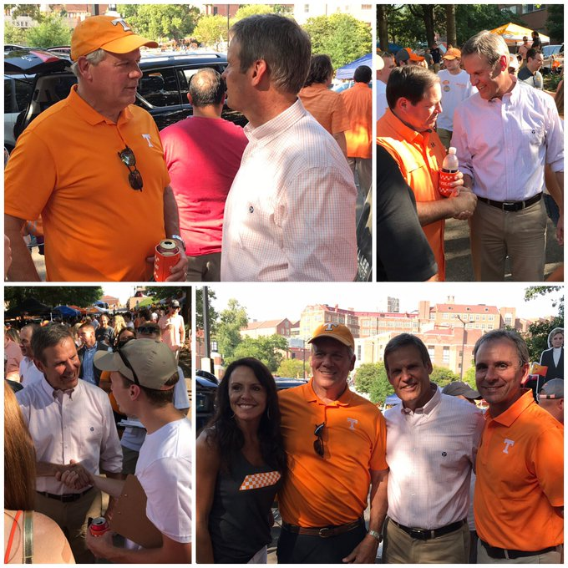](https://twitter.com/BillLeeTN/status/1043629176815792128/photo/1)

[[Neyland Stadium](https://goo.gl/maps/mdMS4Pmu6x4bLq5V9) – Knoxville, TN: 35.954999, -83.924964]

**[Bill Lee](https://twitter.com/BillLeeTN)**

[✔@BillLeeTN](https://twitter.com/BillLeeTN)

It’s football time in Tennessee! We had a great time tailgating before the game today in Knoxville. [#GBO](https://twitter.com/hashtag/GBO?src=hash)

[6:32 PM - Sep 22, 2018](https://twitter.com/BillLeeTN/status/1043629176815792128)

1. These tweets show a different type of marketing with college football. In preparation for the 2018 gubernatorial and US senate elections in Tennessee, then-candidates Marsha Blackburn and Bill Lee visited Knoxville for the Vol’s best-attended football game of 2018 (Cooper 2020): the SEC home opener against rival Florida. The two Republican candidates campaigned together by meeting fans and documenting their tailgating on social media. Both candidates were marketing themselves as worthy governing officials by appealing to the average citizen. College football attendance and tailgating is seen as a popular activity and is, in this case, connected to a state-funded public institution. Both candidates appear to be interacting with orange-wearing Tennessee fans in a very common way with the message that they are not so different from any other Tennessean. Their campaign Twitter accounts use verbiage that a fan might use like “#GBO” (for “go Big Orange”) and the traditional kickoff refrain of “It’s Football Time in Tennessee.” Just as corporations and local stores seek to connect their business and products to the tradition of football, these candidates are using football as a marketing appeal to a popular fandom for their own benefit. Moreover, this photo visually represents an intersection of political power with the geographic space of a public campus. Public higher education campus landscapes have been theorized as arenas for contesting power and social issues (Brasher et al. 2017, Luke & Heynen 2019). The campaigning shown in these tweets represents an active participation of politicians in the public campus arena by wielding football fandom in the hopes of increasing political power.

[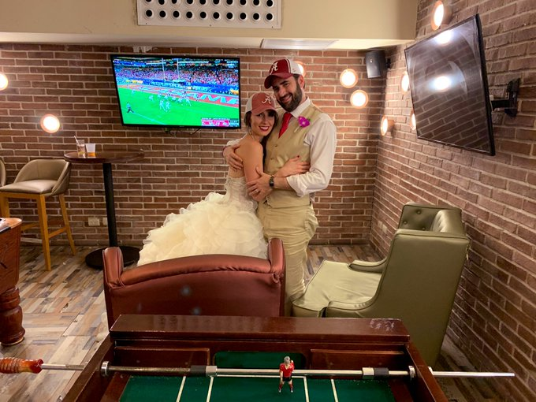](https://twitter.com/SaraGonzalesTX/status/1079198179890028549/photo/1)

[Polygon of the State of Texas]

**[Sara Gonzales](https://twitter.com/SaraGonzalesTX)**

[✔@SaraGonzalesTX](https://twitter.com/SaraGonzalesTX)

TFW you get married on game day. [#RollTide](https://twitter.com/hashtag/RollTide?src=hash) [#RollTideRoll](https://twitter.com/hashtag/RollTideRoll?src=hash)

[10:11 PM - Dec 29, 2018](https://twitter.com/SaraGonzalesTX/status/1079198179890028549)

1. This tweet shows a newlywed couple celebrating their marriage on a gameday for their Alabama Crimson Tide. While it is not necessarily unique, it is still very telling when a couple includes their fandom in wedding pictures. This wedding was held on the same day as one of Alabama’s most important games of the 2018-19 season: the College Football Playoff semifinal. The Tide can be seen on the television in the background running up the score.

[Pan to two-polygon map of Texas & Alabama]

This tweet becomes even more interesting when the identity of the tweeter is revealed to be [Sara Gonzales](https://www.saragonzales.com/), a conservative television pundit living in Texas. With the exception of Florida in 2008 and 2012, every state in the 11-state SEC footprint has designated its Electoral College votes for the Republican candidate in every US presidential election in the twenty-first century. This expression of fandom from a conservative commentator then is a very intriguing intersection of these two attributes of a particular southern culture. It is also interesting to see Crimson Tide fandom transcend the Alabama state borders. State borders play a major role in the bounding of fandom, so this Texan cheering for the Tide speaks to the persistence of anomalies in systems and categorizations.

[Return to first map of the 14 SEC schools & SEC footprint]

Scholars have warned against constructing and studying the region of the US South as essentially unique from everywhere else in the country and world (Wilson 2017), and some have specifically called for an unbounding of the region in the way we discuss it and its attributes (Nagel 2018). For the purposes of this examination into southern football, it means recognizing the ways in which SEC fandom is not constrained to the 11-state conference footprint but is rather part of larger national and international systems. The game of football itself is an imported sport: it developed in the North in the late nineteenth century after it was inherited from England as a modified form of rugby, a modification itself of soccer (Riesman & Denney 1951). And of course, Twitter is an internationally available media that itself allows global access to localized cultures (Stephens & Poorthuis 2015). These remaining tweets explore some ways in which SEC football fandom operates outside of the region of the perceived South.

[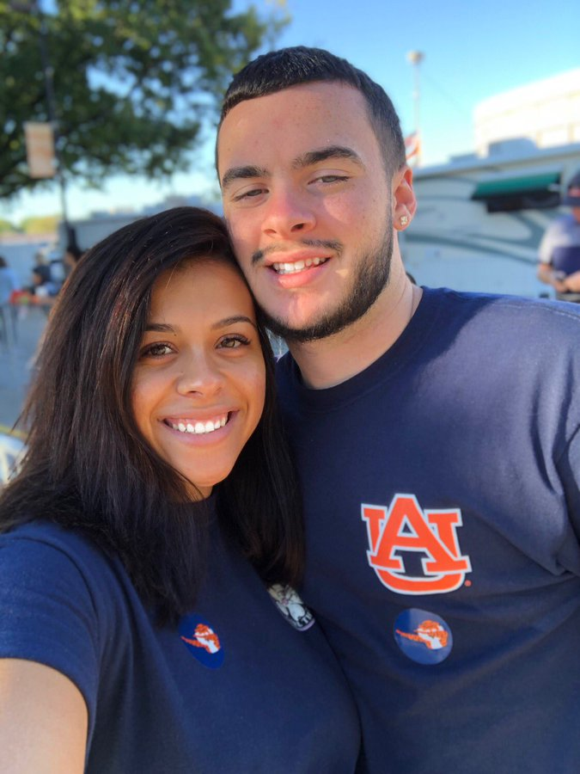](https://twitter.com/MadelynReaves/status/1051124828143534082/photo/1)

[[Jordan-Hare Stadium](https://goo.gl/maps/9KjmTAYkGSwnS51CA) – Auburn, AL: 32.602099, -85.488898]

**[Mad](https://twitter.com/MadelynReaves)**[@MadelynReaves](https://twitter.com/MadelynReaves)

came all the way to Auburn from Delaware just to show him how the south does game days [#WarEagle](https://twitter.com/hashtag/WarEagle?src=hash)

[10:57 AM - Oct 13, 2018](https://twitter.com/MadelynReaves/status/1051124828143534082)

1. This tweeter has journeyed from Delaware to Auburn, Alabama for a football game. This requires either a plane flight or at least a 13 hour drive, a serious tourism travel commitment. The tweet suggests that the tweeter is probably from the South but is at least familiar with and is proud of a connection to the region. Her companion on the other hand is an outsider inexperienced in this ritual of Auburn football. The two seek the authentic tourism experience of southern gameday by wearing the correctly logo-ed gear for the home team. The tweeter seems to assume that Auburn football is representative of an entire regional tradition and that immersion is the best communicator of that tradition. In this tweet, a southern expatriate returns to the region and chooses SEC gameday as a demonstration of an essentially southern ritual. This tourism journey to the spectate can be easily considered a pilgrimage (Baker 2018).

It is worth noting too that these fans are not obviously white. Certainly, ascribing a racial category to otherwise anonymous persons in pictures is tricky and can be problematic. However, it is pertinent here to the discussion of SEC fandom because even the potential of racial ambiguity in the gameday crowd works against the normative notions of whiteness that are subtly instituted and reinforced as the standard of the ideal Southern fan. Whiteness works as a structure of normative privilege (Bonds & Inwood 2016), and this is apparent in southern stadium seats on Saturdays. A more diverse fanbase works to unbound an unassuming white South and its white football fans.

[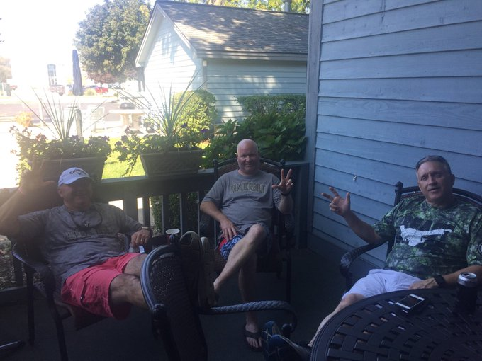](https://twitter.com/cwgleason7/status/1040642358700851200/photo/1)

[South Haven, Michigan]

**[Vandy Panda](https://twitter.com/cwgleason7)**[@cwgleason7](https://twitter.com/cwgleason7)

Tailgating has already begun for the [#SexySix](https://twitter.com/hashtag/SexySix?src=hash) in South Haven [#PureMichigan](https://twitter.com/hashtag/PureMichigan?src=hash) [#AnchorDown](https://twitter.com/hashtag/AnchorDown?src=hash)

[12:44 PM - Sep 14, 2018](https://twitter.com/cwgleason7/status/1040642358700851200)

1. This tweet was sent by a Vanderbilt fan apparently engaged in a reunion with his friends, also Vanderbilt fans, on a Commodore gameday. The group is preparing for the game by remotely tailgating in South Haven, Michigan.

[Show point map of both South Haven, Michigan & Vanderbilt Stadium - Nashville, TN: 36.144075, -86.808860]

South Haven, Michigan, is a small town on Lake Michigan, a considerable distance away from Nashville, Tennessee. These friends, like their campus tailgating counterparts, are outdoors enjoying the company of others in preparation for a football game, but these men are well outside of the SEC footprint. Media has allowed them to keep tabs on the game and participate in the traditional tailgating ritual away from Vanderbilt, and social media has allowed them to be included in the online fan discussion, a virtual tailgate, by using the team’s official hashtag “#AnchorDown”. Despite the distance, this is still an authentic experience of SEC football fandom even in an area where there are probably very few SEC fans.

[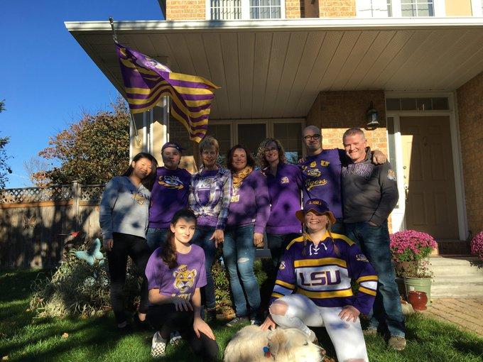](https://twitter.com/cwcegan/status/1053745670706802688/photo/1)

[Polygon of Canada & point of [Tiger Stadium](https://goo.gl/maps/5QBaDQ9hyWFTSHEP6) – Baton Rouge, LA: 30.411961, -91.183838]

**[Cort Egan](https://twitter.com/cwcegan)**[@cwcegan](https://twitter.com/cwcegan)

[@LSUfootball](https://twitter.com/LSUfootball) Tiger tailgating in Canada. [#LSU](https://twitter.com/hashtag/LSU?src=hash) love north of the border [#LSU125](https://twitter.com/hashtag/LSU125?src=hash) [#GeauxTigers](https://twitter.com/hashtag/GeauxTigers?src=hash)

[4:32 PM – Oct 20, 2018](https://twitter.com/cwcegan/status/1053745670706802688)

1. Similarly, this group of LSU fans has congregated together to perform the tailgating ritual in Canada. Kraszewski (2008) would suggest sports-based gatherings like these for displaced fans help them to reconnect with and negotiate understandings of home, and Baker (2018) expands this discussion by highlighting the fluidity of emotion across space. This tweet features the house of at least one of these LSU Canadians. These fans are constructing home by performing the fandom of a sport played beyond their international borders. The house even has a flag in the style of the USA banner with the LSU tiger eye and colors superimposed. This is a potent choice of symbolism for a group of expatriates: they are presenting a symbol commonly displayed in the United States, Louisiana, Baton Rouge, and within Tiger Stadium itself even though they may not usually see the stars and stripes as a part of their daily international cultural landscape, . The tweeter is keenly aware of their expatriate status and uses it to uniquely define this Canadian fan group. One girl in the picture wears an LSU hockey jersey to this tailgate. LSU and indeed no other SEC team has a varsity hockey program, yet she wears the logo of her favorite team much in the same way her peers in Canada might where the ice sport is more popular. And while the #GeauxTigers is meant to invoke the Cajun French spoken in Louisiana, it may hold a double meaning coming from Canada where French is an official language.

[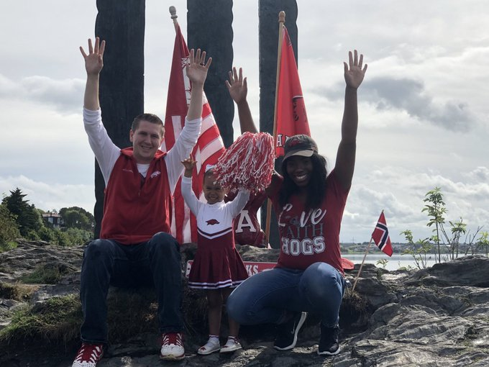](https://twitter.com/Griffraff870/status/1035858928658251777/photo/1)

[Fayetteville, AR: 36.069101, -94.179498]

**[Presley Griffith](https://twitter.com/Griffraff870)**[@Griffraff870](https://twitter.com/Griffraff870)

We ready!! [#Gameday](https://twitter.com/hashtag/Gameday?src=hash) [#WPS](https://twitter.com/hashtag/WPS?src=hash) [#Arkansas](https://twitter.com/hashtag/Arkansas?src=hash) [#Razorbacks](https://twitter.com/hashtag/Razorbacks?src=hash) [#BEATEIU](https://twitter.com/hashtag/BEATEIU?src=hash)

[7:56 AM - Sep 1, 2018](https://twitter.com/Griffraff870/status/1035858928658251777)

1. This tweet completely subverts normative notions of SEC football fandom. This tweet shows a still image of the performative ritual for Arkansas Razorbacks fans: Calling the Hogs. A man, his wife, and their daughter are doing the calling, and they all are outfitted in Arkansas garb. The mother’s shirt plays upon the “Family Faith Football” mantra, and the daughter is dressed much like the [young Alabama fan](https://t.co/nnhkX0eu5H) from above. This family structure is not one considered normative in the South however; this is an interracial family, and the daughter is mixed-race. Such relationships and family structures were considered taboo in the US South until relatively recently, and they can still be viewed as subversive (Djamba & Kimuna 2014). If SEC football fandom and whiteness are both seen as ideally Southern, then the support for the Razorbacks within this interracial family structure could certainly be subversive.

[Point map at [Sverd I fjell, Norway](https://goo.gl/maps/faQdPwmUDBmfCFwWA): 58.941605, 5.672137]

Perhaps this family feels more at ease performing their fandom because they are in a different country. The location from which this tweet was sent is vital in understanding this unbounded fandom. There are three flags in this picture: one with the Arkansas logo, one like the LSU flag in the previous tweet that superimposes the Hogs’ logo and colors on the American flag, and the Norwegian flag. These SEC fans are actually performing the traditional Fayetteville, Arkansas, ritual in Norway. Even the background of this shot is significant: these fans are at [Sverd i fjell](https://en.wikipedia.org/wiki/Sverd_i_fjell) (English: Swords in rock), a commemorative Norwegian monument.

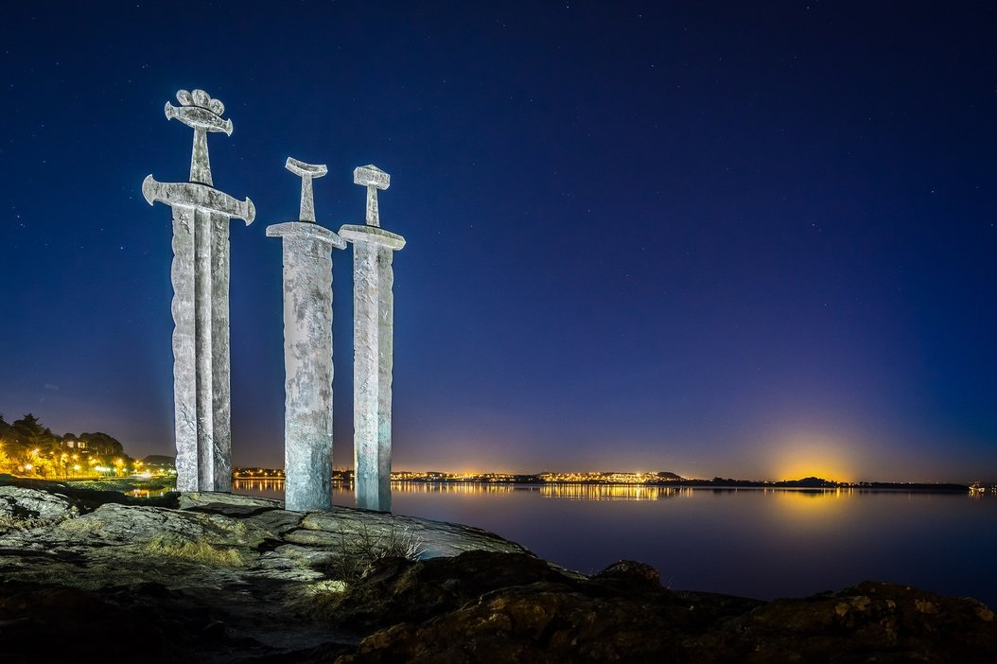

Sverd i fjell in Norway | <https://imgur.com/gallery/KOJeOCb>

[2 point map: 1 at Sverd I fiell, Norway and other at Razorback Stadium – Fayetteville, AR: 36.069101, -94.179498]

These fans are outside of Arkansas, the South, the United States, and North America. The vernacular Norwegian understanding of “football” is a game played with a round ball and goals. This shot is intended to highlight the international nature of this family’s fandom: flags of both the US and Norway are present, and the iconic ritual of Arkansas fandom is performed in front of a Norwegian icon. In fact, the tweet before this one from the same sender includes a video of not only this couple but a whole group of Arkansas fans calling the hogs from this site:

[[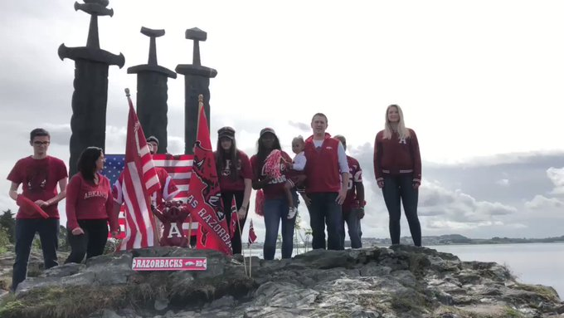](https://twitter.com/Griffraff870/status/1035589681759576064)](https://twitter.com/Griffraff870/status/1035589681759576064)

**[Presley Griffith](https://twitter.com/Griffraff870)**[@Griffraff870](https://twitter.com/Griffraff870)

[#ONEHogCall](https://twitter.com/hashtag/ONEHogCall?src=hash) [pig emoji x3] All the way from Norway! [#BeatEIU](https://twitter.com/hashtag/BeatEIU?src=hash) [#Arkansas](https://twitter.com/hashtag/Arkansas?src=hash) [#Razorbacks](https://twitter.com/hashtag/Razorbacks?src=hash)

[2:06 PM - Aug 31, 2018](https://twitter.com/Griffraff870/status/1035589681759576064)

This was even picked up by the SEC Network, the conference’s premier US-based media apparatus, and displayed to fans watching the game because of the unique, unusual, and highly devoted expression of fandom.

[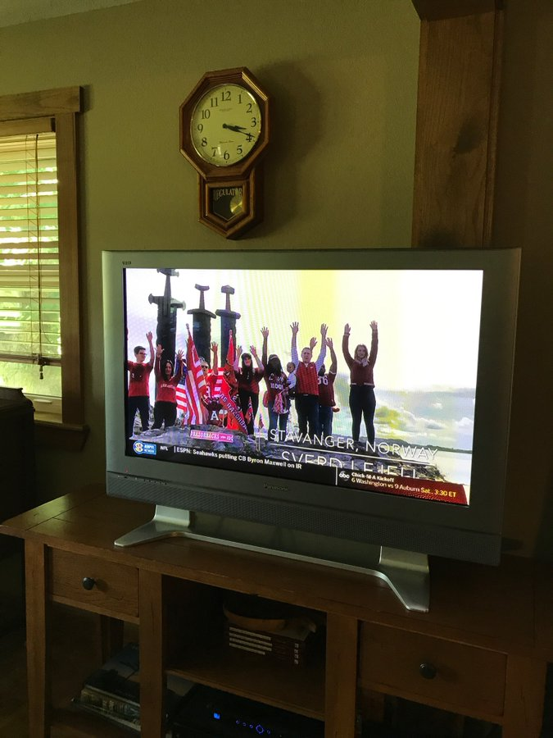](https://twitter.com/Griffraff870/status/1035988388535590912/photo/1)

**[Presley Griffith](https://twitter.com/Griffraff870)**[@Griffraff870](https://twitter.com/Griffraff870)

Catch me on the [@SECNetwork](https://twitter.com/SECNetwork) [#Arkansas](https://twitter.com/hashtag/Arkansas?src=hash) [#Razorbacks](https://twitter.com/hashtag/Razorbacks?src=hash) [#WPS](https://twitter.com/hashtag/WPS?src=hash)

[4:30 PM - Sep 1, 2018](https://twitter.com/Griffraff870/status/1035988388535590912)

Once again, we see the use of American football fandom used to help negotiate notions of home in physical spaces far removed from the spectate and the fluidity of emotions across that space. Twitter as a social media platform has made it easier to construct and participate in ever-expanding virtual fandoms in the internet age (Bale 1998).

Note

1. The search query used on Twitter’s advanced search GUI for pictures:

*(game day OR tailgating) (#SEC OR #HailState OR #HottyToddy OR #RollTide OR #WPS OR #CommitToTheG OR #WeAreUK OR #PoweredByTheT OR #WarEagle OR #BBN OR #GeauxTigers OR #AnchorDown OR #GoGators OR #RockyTop OR #GBO OR #MIZZOU OR #UGA OR #GigEm) since:2018-08-01 until:2019-01-08*

Hashtags were gleaned either from the official football accounts of the SEC schools or by recognition of popular usage during research.

1. South Carolina’s mascot of Gamecocks would not return search results on Twitter for its potentially graphic homonym, and #USC returned mostly material on the University of Southern California.

References

Alderman, D. H. 2015. When Exotic Becomes Native: Taming, Naming, and Kudzu as Regional Symbolic Capital. *Southeastern Geographer* 55(1): 32-56.

Alderman, D. H. and R. M. Beavers. 1999. Heart of Dixie Revisited: An Update on the Geography of Naming in the American South. *Southeastern Geographer* 39 (2): 190-205.

Alderman, D. H. and D. B. Good. 1997. Exploring the Virtual South: the Idea of a Distinctive Region on ‘the Web.’ *Southeastern Geographer* 37 (1): 20-45.

Anderson, B. 2016. *Imagined Communities: Reflections on the Origin and Spread of Nationalism* revised ed. New York: Verso.

Arthur, R. and H. T. P. Williams. 2019. The human geography of Twitter: Quantifying regional identity and inter-region communication in England and Wales. *PloS one* 14 (4): e0214466. DOI: 10.1371/journal.pone.0214466.

Baker, T. A. 2018. Long-Distance Football Fandom: Emotional Mobilities and Fluid Geographies of Home. *Social & Cultural Geography.* Advance online publication: 1-17. DOI: 10.1080/14649365.2018.1563709.

Bale, J. 2003. *Sports Geography*. New York: Routledge.

Bale, J. 1998. Virtual Fandoms: Futurescapes of Football. In *Fanatics!: Power, Identity, and Fandom in Football,* edited by A. Brown, 168-202. Psychology Press.

Bever, M. L. 2011. Fuzzy Memories: College Mascots and the Struggle to Find Appropriate Legacies of the Civil War.*Journal of Sport History* 38 (3): 447-463.

Bohland, J. D. 2013. Look Away, Look Away, Look Away to Lexington: Struggles over Neo-Confederate Nationalism, Memory, and Masculinity in a Small Virginia Town. *Southeastern Geographer* 53 (3): 267-295.

Bonds, A. and J. Inwood. 2016. Beyond White Privilege: Geographies of White Supremacy and Settler Colonialism. *Progress in Human Geography*40 (6): 715-733.

Brasher, J. P., Alderman, D. H., and Inwood, J. F. J. 2017. Applying critical race and memory studies to university place naming controversies: Toward a responsible landscape policy. *Papers in Applied Geography* 3 (3-4), pp.292-307.

Brunn, S. D., G. R. Webster, and J. C. Archer. 2011. The Bible Belt in a Changing South: Shrinking, Relocating, and Multiple Buckles.” *Southeastern Geographer* 51 (4): 513-549.

Cooper, C. A., and H. G. Knotts. 2017. *The Resilience of Southern Identity: Why the South Still Matters in the Minds of Its People*. Chapel Hill, NC: UNC Press Books.

Cooper, J. A. 2020. Making orange green? A critical carbon footprinting of Tennessee football gameday tourism. *Journal of Sport & Tourism* 24 (1): 31-51. DOI: [10.1080/14775085.2020.1726802](https://doi.org/10.1080/14775085.2020.1726802)

Dillette, A. K., S. Benjamin, and C. Carpenter. 2019. Tweeting the Black Travel Experience: Social Media Counternarrative Stories as Innovative Insight on #TravelingWhileBlack. *Journal of Travel Research* 58 (8): 1357-1372. DOI: 10.1177/0047287518802087.

Djamba, Y. K., and S. R. Kimuna. 2014. Are Americans Really in Favor of Interracial Marriage? A Closer Look at when they are Asked about Black-White Marriage for their Relatives.” *Journal of Black Studies* 45 (6): 528-544.

Epley, N., J. Schroeder, and A. Waytz. 2013. Motivated Mind Perception: Treating Pets as People and People as Animals.” In *Objectification and (De) Humanization*, 127-152. New York, NY: Springer.

Geertz, C. 1972. Deep Play: Notes on the Balinese Cockfight. *Daedalus*101 (1): 1-37.

Gumprecht, B. 2008. *The American College Town*. Amherst, MA: University of Massachusetts Press.

Haenschen, K. 2016. Social pressure on social media: Using Facebook status updates to increase voter turnout. *Journal of Communication* 66 (4): 542-563. doi: 10.1111/jcom.12236.

Hetherington, W. 1993. Sports tourism facility management functions. *Journal of Sport Tourism* 1 (1): 18-20.

Hills, M. 2002. *Fan Cultures.* New York: Routledge.

Hinch, T., and S. Kono. 2018. Ultramarathon Runners’ Perception of Place: a Photo-Based Analysis. *Journal of Sport & Tourism* 22 (2): 109-130.

Kraszewski, J. 2008. Pittsburgh in Fort Worth: Football Bars, Sports Television, Sports Fandom, and the Management of Home. *Journal of Sport and Social Issues* 32 (2): 139-157.

Lauder, T. 2012. Southern Identity in Southern Living Magazine. *Journal of Geography* 111 (1): 27-38.

Lee, D., G. T. Trail, H. H. Kwon, and D. F. Anderson. 2011. Consumer Values Versus Perceived Product Attributes: Relationships among Items from the MVS, PRS, and PERVAL Scales. *Sport Management Review* 14 (1): 89-101.

Luke, N. and Heynen, N. 2019. Abolishing the frontier: (De)colonizing ‘public’education. *Social & Cultural Geography*. doi: 10.1080/14649365.2019.1593492.

Menaker, B. E., and B. H. Chaney. 2014. College Football Game Day Stadium Incidents: Policy and Environmental Effects on Alcohol-Related Ejections and Crime. *Journal of Policy Research in Tourism, Leisure and Events* 6 (2): 119-134.

Metzger, M. M., R. Bonneau, J. Nagler, and J. A. Tucker. 2016. Tweeting Identity? Ukrainian, Russian, and #Euromaidan. *Journal of Comparative Economics* 44 (1): 16-40.

Morgan, L. J. and T. Klimasewski. 2015. Pigskin Power Region: Dominance of Southern Collegiate Football. *Southeastern Geographer* 55 (2): 214-224.

Nagel, C. R. 2018. Southern Exceptionalism and the Perils of Region. *The Professional Geographer* 70 (4): 678-686.

Poorthuis, A., M. Zook, M. Graham, T. Shelton, and M. Stephens. 2016. Using Geotagged Digital Social Data in Geographic Research.” In *Key Methods in Geography*, edited by Clifford, N., M. Cope, T. W. Gillespie, and S. French, 248-269. Los Angeles, CA: Sage.

Polese, A. 2018 Building a Ukrainian Identity in Odessa: Negotiation of Markers and Informal Nationalism. *Otoritas: Jurnal Ilmu Pemerintahan* 8 (1): 1-16.

Reed, J. S. 1976. The heart of Dixie: An essay in folk geography. *Social Forces* 54 (4): 925-939.

Riesman, D. and R. Denney. 1951. Football in America: A Study in Cultural Diffusion. *American Quarterly* 3 (4): 309-325.

Roseman, C. C. and F. M. Shelley. 1988. The Geography of Collegiate Football Radio Broadcasting.*Sport Place* 2 (2): 42-50.

Steinfeldt, J. A., G. A. Gilchrist, A. W. Halterman, A. Gomory, and M. C. Steinfeldt. 2011. Drive for Muscularity and Conformity to Masculine Norms among College Football Players. *Psychology of Men & Masculinity* 12 (4): 324-338.

Stephens, M., & Poorthuis, A. (2015). Follow thy neighbor: Connecting the social and the spatial networks on Twitter. *Computers, Environment and Urban Systems*. 53: 87-95.

Turner, Victor. 1969. *The Ritual Process: Structure and Anti-Structure*. Chicago: Aldine Publishing.

Urry, J. 2002. *The Tourist Gaze* 2nd ed. London: Sage Publishing.

Webster, G. R., and J. I. Leib. 2016. Religion, Murder, and the Confederate Battle Flag in South Carolina. *Southeastern Geographer.* 56 (1): 29-37.

Wilson, C. R. 2017. Reimagining Southern Studies: time and space bodies and spirits. In*Navigating Souths: Transdisciplinary Explorations of a U.S. Region,* edited by Coffey, M. G. and J. Skipper, 21-54*.* Athens, GA: University of Georgia Press.

Wise, N. & G. Z. Kohe. 2020. Sports geography: new approaches, perspectives and directions. *Sport in Society* 23 (1): 1-10. DOI: 10.1080/17430437.2018.1555209

Acknowledgements

A note of thank to Dr. Derek H. Alderman of the University of Tennessee, Knoxville for his advice and support throughout this photo essay’s conception and refinement. I would also like to thank Dr. Jordan P. Brasher for his guidance through the publication process. Finally, I would like to thank the editors of *FOCUS on Geography* and staff of the AGS for their longstanding cooperation throughout the publication process.

Author Identification

J. A. Cooper

The University of Tennessee, Knoxville

Masters of Science Graduate -- Department of Geography

jacooper1317@gmail.com

<https://orcid.org/0000-0002-4334-4079>